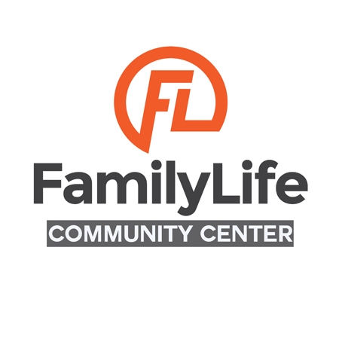

Application For Use

Date of Application: __________________ Date of Event: __________________

Name of Event: _______________________________________________________

Name of Business or Individual Applying: __________________________________

Contact Person: _______________________________________________________

Address (Street and PO Box): ____________________________________________

Phone: __________________ Email: __________________________________

Expected Attendance: _____________

Description of Function: __________________________________________________________
____________________________________________________________________
____________________________________________________________________

Event Start Time: ___________________ Event End Time: ___________________

Products being sold? ____ Yes ____ No

If yes, please describe___________________________________________________

Please complete and return this application along with the attached signed agreement and security deposit check or money order of $250. Please make checks payable to: Family Life Community Center. Please note that Family Life DOES NOT hold checks. Checks are processed upon receipt. Family Life DOES NOT accept payments with cash.
We recommend that you retain a photocopy of all forms for your records.
MC/VISA Card Number_______________________________ Exp. Date ___________
Name on card: ______________________________________________________________
Check # ______________ Money Order _________________ Approval Code ________

Cafe
Rental Rates & Fees:
$75.00 per hour (includes large counter space and sink)
Security Deposit: $250 (refundable terms and conditions apply)
Custodian Fee: $50 (to set up room, an additional fee of $25 is required)
Cafe Rental Policy:
The following Rental Policy contains important information regarding the use of the cafe. It is imperative that you read and review the items listed.
- The facility is a NO SMOKING facility. Please note: Alcoholic Beverages and controlled substances of any kind are not permitted on the premises. Any violation of this will result in person(s) being asked to leave the facility and premises.
- Decorations shall be free standing. No taping, nailing, stapling or tacking of décor to walls, ceilings or fixtures. If décor is taped to windows, windows must be free of all tape and marks and cleaned at the end of usage. No glitter or party shapes permitted.
- Any furniture moved must be returned to its original position.
- A $250.00 security deposit is required and must be paid in full once the contract has been signed in order to secure the rental space. The security deposit will be returned within 15 business days if there are no damages. If damages are found, the security deposit shall be retained as to that portion which is necessary to repair damages. If the cost of said repairs exceed $250.00, damage charges will be invoiced by Family Life Community Center to the customer and shall be paid in full no later than one month following the date of invoice. A 1.5% monthly service charge will be assessed for non-payment following the initial 30 days. The customer shall be responsible for attorney fees and court cost required to recover payment and interest on said invoice, as well as any and all charges and fees incurred for checks that fail to be honored by their bank for any reason.
- The customer will be charged the cost of regular rental fee for going over agreed time.
- Rental fees must be paid in full (10) business days prior to the event.
- Cancellations made in writing two (2) weeks prior to the requested reserved date will be fully refundable. Otherwise, those requesting the use may be responsible for payment of cost as stated on the approved application form.
- The customer agrees to release Family Life from all liability due to loss, theft, personal injury or property damages that may occur to any person or property thereon during the period of occupancy.
- Family Life Community Center reserves the right to cancel any scheduled use of the cafe if operations should require it. In such case, every reasonable effort will be made to provide the customer with adequate advance notice.
- A Family Community Center representative will be available at the beginning of occupancy and set up time of the event and at the end of the event.
- For questions call or email (434) 534-6904 or community@familylifelynchburg.org

By signing below the member agrees to adhere to the policies set by Family Life Community Center:

Date: _______________ Name: _________________________________________

Signature: ___________________________________________________________

Family Life Community Center Board of Directors Approval:

______________ _____________________________________________________
Date BOD Name/ Signature
______________ ________________________________________________________
Date BOD Name/ Signature

Revised 12/13/18 admin

