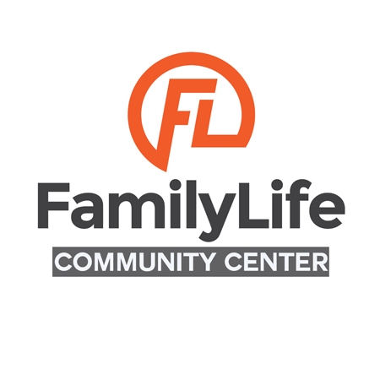

Application For Use

Date of Application: __________________ Date of Event: __________________

Name of Event: _______________________________________________________

Name of Business or Individual Applying: __________________________________

Contact Person: _______________________________________________________

Address (Street and PO Box): ____________________________________________

Phone: __________________ Email: ________________________

Expected Attendance: _____________

Description of Function:
____________________________________________________________________
____________________________________________________________________
____________________________________________________________________
____________________________________________________________________

Event Start Time: ___________________ Event End Time: ___________________

Please complete and return this application along with the attached signed agreement and security deposit check or money order of $250. Please make checks payable to: Family Life Community Center. Please note that Family Life DOES NOT hold checks. Checks are processed upon receipt. Family Life DOES NOT accept payments with cash.

We recommend that you retain a photocopy of all forms for your records.
MC/VISA Card Number _______________________________ Exp. Date __________
Name on card: ________________________________________________________
Check # _____________ Money Order: _____________ Approval Code _________

Gymnasium
Rental Rates & Fees:
$100 per hour
Security Deposit: $250 (refundable terms and conditions apply)
Custodian Fee: $50 (to set up room, an additional fee of $25 is required)
Available times for Rental:
Monday, Tuesday, Wednesday (until 5pm), Thursday thru Saturday and closed on Sunday
Gym Rental Policy
The following Rental Policy contains important information regarding the use of the gym. It is imperative that you read and review the items listed. Failure to comply with any of the rules will result in denial of future use of the facilities.
- The facility is a NO SMOKING facility. Any violation of this will result in person(s) being asked to leave the facility.
- Only shoes with non-marking soles are allowed in the gymnasium area. Scooters, wheeled shoes, skateboards, bicycles, tricycles, roller blades, or other wheeled recreational /exercise equipment are not permitted on the gymnasium floor.
- No Alcoholic beverages or controlled substances of any kind will be permitted on Family Life Property at any time.
- Foul language and horse playing are not permitted in the building.
- Programs and activities of user/groups must be lawful and in conformity with all policies of Family Life.
- Rental fees must be paid in full (10) business days prior to the event.
- The customer will be charged the cost of regular rental fee for going over agreed time.
- Cancellations made in writing two (2) weeks prior to the requested reserved date will be fully refundable. Otherwise, those requesting the use may be responsible for payment of cost as stated on the approved application form.
- The customer shall indemnify and hold harmless Family Life, its employees and volunteers from any liability for damages, loss, or injury the customer his/her guest might incur while using the premises under this agreement.
- Rental agreements are NOT transferrable.
- Family Life Community Center reserves the right to cancel any scheduled use of the Gym if operations should require it. In such case, every reasonable effort will be made to provide the customer with adequate advance notice.
- The applicant should verify that they are an adult, the age of twenty one (21).
An adult 21 years of age or older must accompany all groups. This supervisor must be with the group at all times during the rental time period. It is the responsibility of the supervising adult to ensure that the participants remain within the designated rental area and that damage to the building and grounds does not occur and that all group participants leave the gym on or before the end of the time of rental permit. The customer will be charged $50.00 for each additional 15 minutes over the agreed time of rental.
- A $250.00 security deposit is required and must be paid in full once the contract has been signed in order to secure the rental space. The security deposit will be returned within 15 business days if there are no damages. If damages are found, the security deposit shall be retained as to that portion which is necessary to repair damages. If the cost of said repairs exceed $250.00, damage charges will be invoiced by Family Life Community Center to the customer and shall be paid in full no later than one month following the date of invoice. A 1.5% monthly service charge will be assessed for non-payment following the initial 30 days. The customer shall be responsible for attorney fees and court cost required to recover payment and interest on said invoice, as well as any and all charges and fees incurred for checks that fail to be honored by their bank for any reason.
- If requested by Lessor, customer shall provide proof of insurance with sufficient coverage as designated by Lessor.
- For questions call or email (434) 534-6904 or community@familylifelynchburg.org

By signing below the customer agrees to adhere to the policies set by Family Life Community Center:

Date: _______________ Name: _________________________________________

Signature: ___________________________________________________________

Family Life Community Center Board of Directors Approval:

______________ _____________________________________________________
Date BOD Name/ Signature
______________ ________________________________________________________
Date BOD Name/ Signature

